8.35: The speed of the block immediately after being struck by the bullet may be found from either force or energy considerations. Either way, the distance s is related to the speed 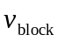by 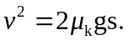 The speed of the bullet is then
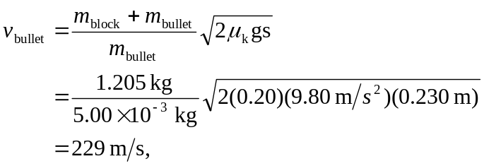

or 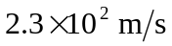 to two places.

